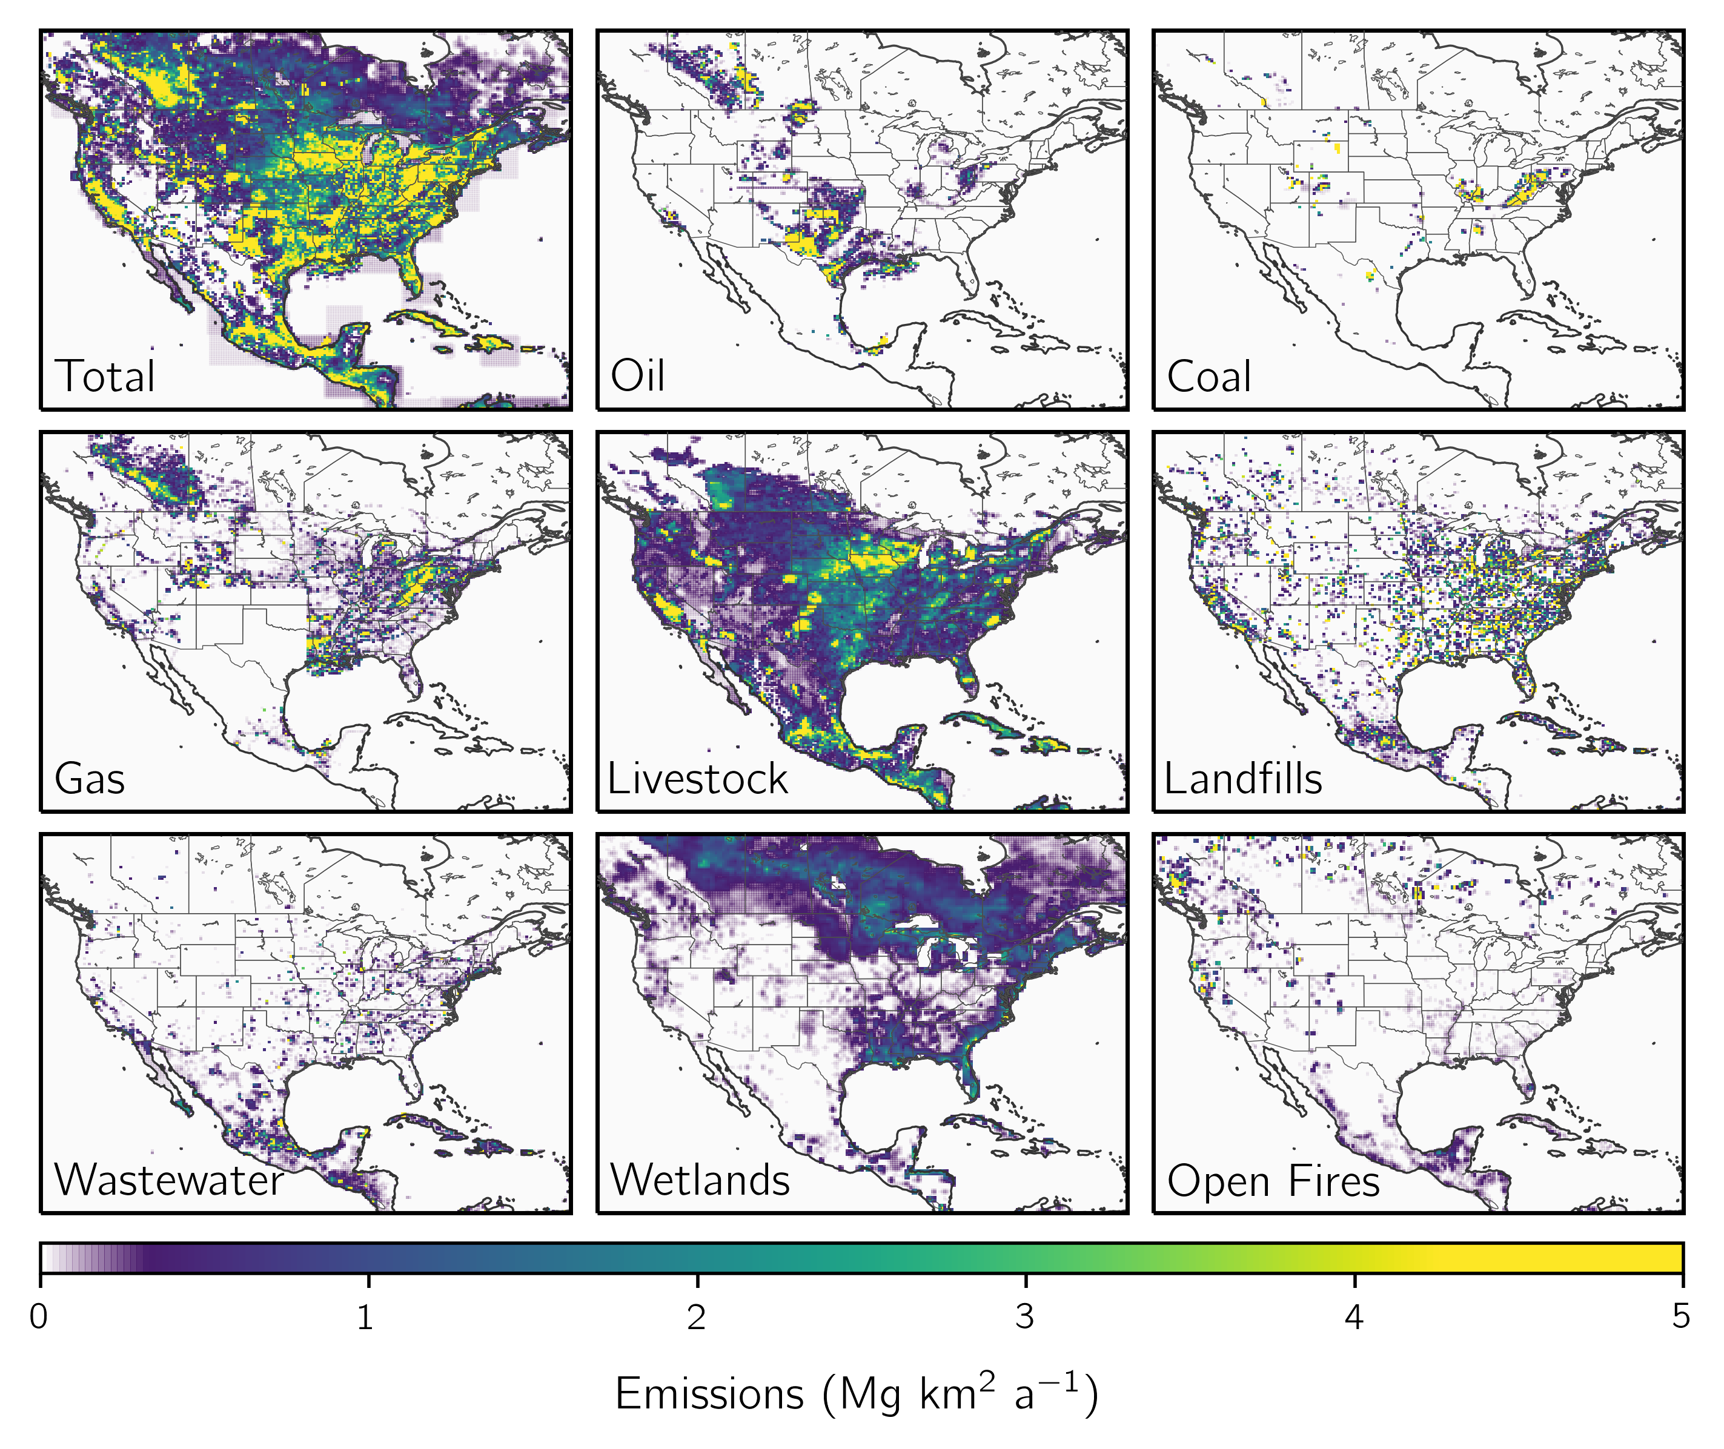

**Figure 1:**

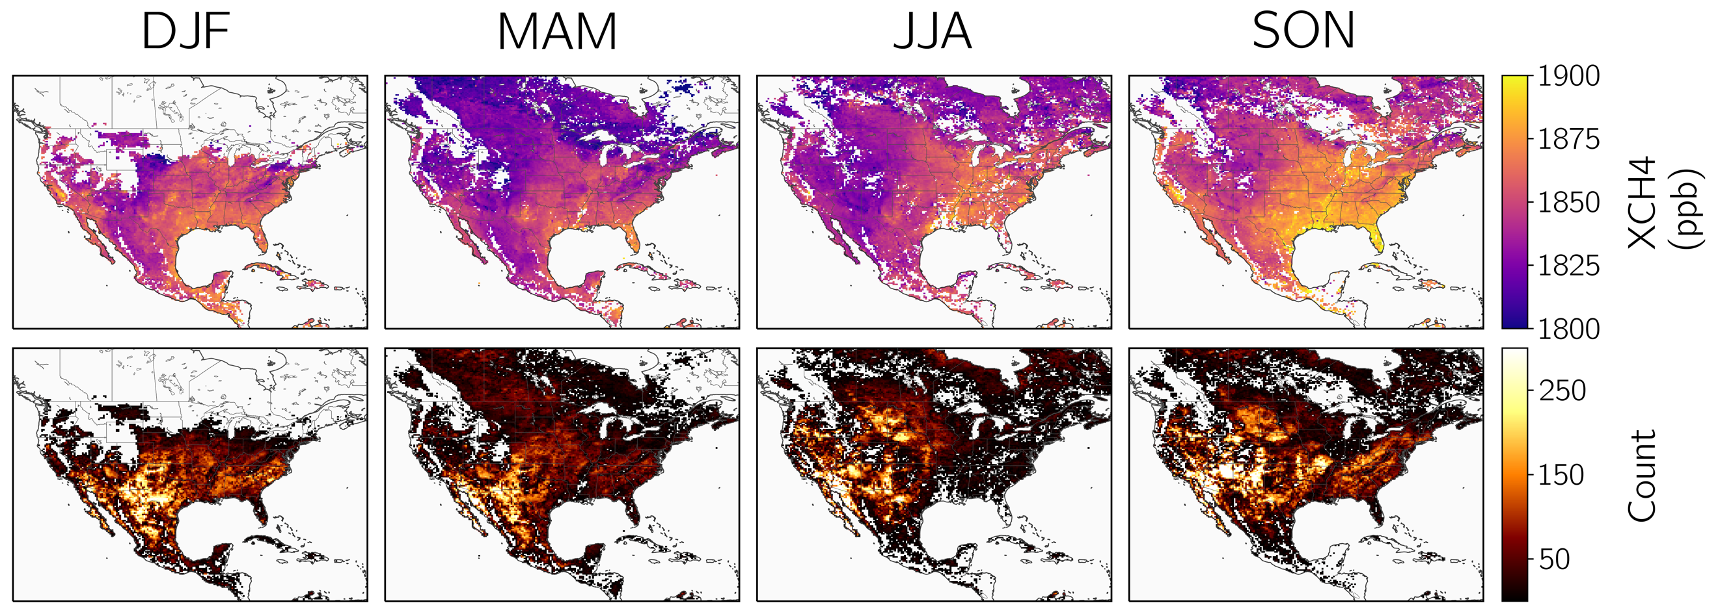

**Figure 2:**

**Figure 3:**

|  |  |  |  |  |  |  |  |
| --- | --- | --- | --- | --- | --- | --- | --- |
| **Base inversions**[1] | | | **Inversion parameters**[2] | | **Ensemble member evaluation**[3] | | |
| **Wetland inventory**[4] | **Optimized boundary conditions**[5] | **Latitude correction**[6] | **Regularization factor**[7] | **Prior error standard deviation**[8] | **J**A**(x̂)/n**f[9] | **Percentage of negative values**[10] | **Optimized grid cells**[11] |
| Scaled | Yes | Yes | 0.3 | 0.75 | 1 | 4.5 | 4655 |
| 0.5 | 1 | 1 | 9.6 | 5490 |
| Scaled | Yes | No | 0.25 | 0.75 | 1 | 4.5 | 4467 |
| 0.4 | 1 | 1 | 9.4 | 5353 |
| Scaled | No | Yes | 0.15 | 0.5 | 1 | 1.5 | 2592 |
| 0.25 | 0.75 | 1 | 5.3 | 4468 |
| Scaled | No | No | 0.15 | 0.75 | 1 | 5.6 | 3872 |
| Subsetted | Yes | Yes | 0.2 | 0.5 | 1 | 1.5 | 3692 |
| 0.45 | 0.75 | 1 | 5.5 | 5661 |
| Subsetted | Yes | No | 0.175 | 0.5 | 1 | 1.6 | 3435 |
| 0.3 | 0.75 | 1 | 4.9 | 5327 |
| 0.5 | 1 | 1 | 9.4 | 6067 |
| Subsetted | No | Yes | 0.175 | 0.5 | 1 | 1.8 | 3443 |
| 0.35 | 0.75 | 1 | 5.9 | 5476 |
| Subsetted | No | No | 0.175 | 0.75 | 1 | 6.2 | 4759 |

1. The ensemble is composed of eight base inversions, which vary the wetland inventory, the use of boundary condition correction elements, and the use of a latitudinal correction for the model – observation difference.
2. For each of the base members, the magnitude of the observational error covariance matrix as defined by the regularization factor $γ$ is balanced against the magnitude of the prior error standard deviation.
3. The regularization factor and prior error standard deviation are chosen to meet three criteria defined by the average cost function value, the percentage of negative values, and the number of optimized grid cells.
4. The ensemble of inversions includes two wetland inventories: "scaled" decreases the high performance WetCHARTs ensemble v1.3.1 by a factor of 4.04, while "subsetted" removes two ensemble members that have anomalously high methane emissions in the high northern latitudes.
5. In inversions with optimized boundary conditions, we include in the inversion state vector four boundary condition elements corresponding to the northern, eastern, southern, and western borders of the North American domain.
6. In inversions with a latitudinal correction, we correct the latitudinal bias in the model – observation difference with a first order polynomial. In inversions without a latitudinal correction, we remove the mean model – observation difference.
7. The regularization factor $γ$ is applied to the inverse observational error covariance matrix so that smaller values increase errors.
8. The relative prior error standard deviation is assumed constant for all grid cells.
9. We require that the average of the cost function evaluated at the posterior emissions is equal to 1 following the chi-square distribution. We include only grid cells optimized by the inversion (averaging kernel sensitivities $≥$ 0.05) in the average. We exclude any boundary condition elements from this calculation, though they are unlikely to change the result.
10. We require that fewer than 10% of the optimized grid cells be negative.
11. We require that each inversion optimizes at least one grid cell per model run, or more than 2386 grid cells.